Intro:
Psalm 119:94-104 “Oh how I love your law! It is my meditation all the day. Your commandment makes me wiser than my enemies, for it is ever with me. I have more understanding than all my teachers, for your testimonies are my meditation. I understand more than the aged, for I keep your precepts. I hold back my feet from every evil way, in order to keep your word.
I do not turn aside from your rules, for you have taught me. How sweet are your words to my taste, sweeter than honey to my mouth! Through your precepts I get understanding; therefore I hate every false way.”

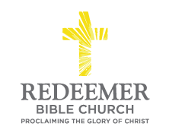
Ty DaCosta / Morning Service / El Corazon Senior Center / Oceanside, CA / August 1, 2021
The Sweetness of God’s Word
Psalm 119:97-104
- Preaching Point: God gave you this passage today that ________________
.

- God’s Word is Y D – v.97

- God’s Word B True W - vv.98-100

- God’s Word P____________________ P____________________________

Conclusion:

