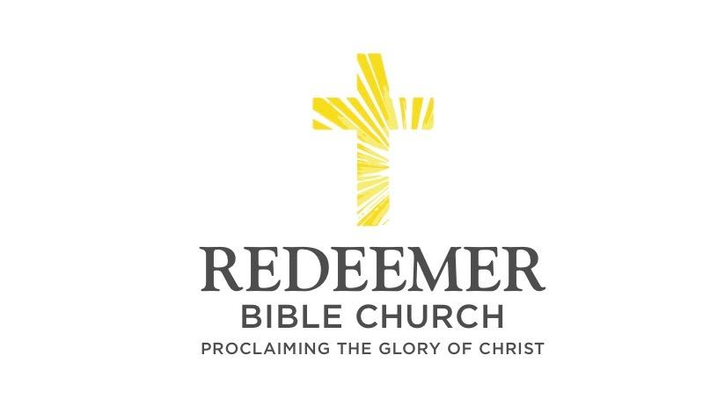
Luke 9:57-62
“57 As they were going along the road, someone said to Him, "I will follow You wherever You go." 58 And Jesus said to him, "The foxes have holes and the birds of the air [have] nests, but the Son of Man has nowhere to lay His head." 59 And He said to another, "Follow Me." But he said, "Lord, permit me first to go and bury my father." 60 But He said to him, "Allow the dead to bury their own dead; but as for you, go and proclaim everywhere the kingdom of God." 61 Another also said, "I will follow You, Lord; but first permit me to say good-bye to those at home." 62 But Jesus said to him, "No one, after putting his hand to the plow and looking back, is fit for the kingdom of God."

The Cost of Following Christ
Luke 9:57-62

Andre Enriquez / RBC Worship Service / Enriquez Home / Vista, CA / March 28, 2021

Intro:

- Preaching Point: God gave you this passage ___________________________ ________________________________________________________________.

- R______________ to l___________ your c________________ to follow Christ - vv.57-58

- R______________ w_____________ h_________________ when Christ calls you to follow Him - vv.59-60

- R______________ to p__________ your p_____________ before following Christ - vv.61-62

Conclusion:

