Redeeming Sexual Morality
Selected Passages
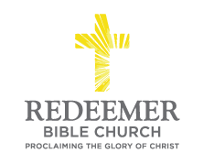
Angelo L. Tolentino / Morning Service / El Corazon Senior Center / Oceanside, CA / January 16, 2022

Preaching Point: This morning, our prayer is that God’s Word would _______________________________
__________________________________________________________________________________________
__________________________________________________________________________________________

- God’s _____________ of ___________ ______________ is ________________.

- God’s _____________ on ______________ Immorality is ____________-.

- God’s ________________ of the ___________ ____________ is ________________.

Conclusion:

