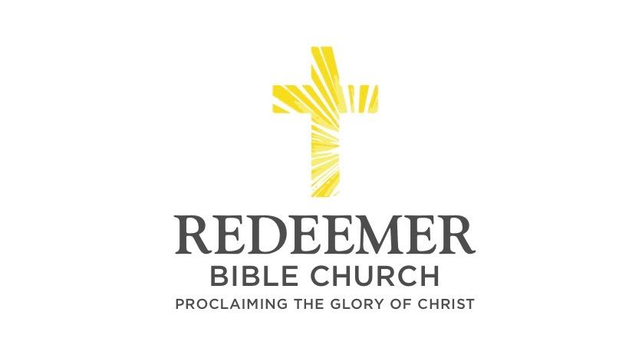
The Goodness of God’s Word
Psalm 119:65-72
Psalm 119:65-72 “⁶⁵ You have dealt well with Your servant, O LORD, according to Your word. ⁶⁶ Teach me good discernment and knowledge, For I believe in Your commandments. ⁶⁷ Before I was afflicted I went astray, But now I keep Your word. ⁶⁸ You are good and do good; Teach me Your statutes. ⁶⁹ The arrogant have forged a lie against me; With all [my] heart I will observe Your precepts. ⁷⁰ Their heart is covered with fat, [But] I delight in Your law. ⁷¹ It is good for me that I was afflicted, That I may learn Your statutes. ⁷² The law of Your mouth is better to me Than thousands of gold and silver [pieces.]”

Andre Enriquez / Morning Service / El Corazon Sr. Ctr. / Oceanside, CA / July 25, 2021

Intro:
- Preaching Point: God gave you this passage, so that______________________ ________________________________________________________________.

- Goodness T_______________ S_______________ - vv.65-67

  - C___________ the Goodness of God’s Word through your a____________- v.65

  - C_____________ for the goodness of God’s Word - v.66

- Goodness P______________ W______________ - vv.68-72

  - C________________ in the goodness of God’s Word - v.68

  - C________________ to the goodness of God’s Word - vv.69-71

  - C________________ the goodness of God’s Word - v.72

Conclusion:

