Romans 12:1-2
“Therefore I urge you, brothers and sisters, by the mercies of God, to present your bodies as a living and holy sacrifice, ^{[a]}acceptable to God, which is your ^{[b]}spiritual service of worship. ² And do not be conformed to this ^{[c]}world, but be transformed by the renewing of your mind, so that you may ^{[d]}prove what the will of God is, that which is good and ^{[e]}acceptable and perfect.”

The Elements of Worship: 3) Serving God
Romans 12:1-2
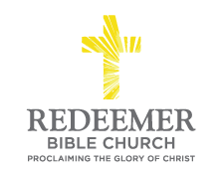
Angelo L. Tolentino / Morning Service / El Corazon Senior Center / Oceanside, CA / July 4, 2021

Intro:

- Preaching Point: God gave this passage ________________________________ __________________________________________________________________.

- R_____________________ God, v1a, v2a

- S___________________ to God, v1b

- S____________________ God, v1c, 2b

Conclusion:

