“She will give birth to a Son; and you shall name Him Jesus, for He will save His people from their sins.”
Matthew 1:21

The Savior Has Come
Matthew 1:21
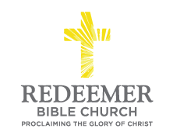
Angelo L. Tolentino / Christmas Morning Service / El Corazon Senior Center / Oceanside, CA / December 26, 2021

Intro:
Preaching Point: This morning’s passage is given to you so that _____________________________________________________
_____________________________________________________
_____________________________________________________

- The __________ ___________ of Christ’s Mission, v21a

- The ____________ ______________ of Christ’s Mission, v21b

- The ___________ __________________ of Christ’s Mission, v21c

Conclusion:

