Luke 23:39-43
“³⁹ One of the criminals who were hanged there was ^{[a]}hurling abuse at Him, saying, ‘Are You not the ^{[b]}Christ? Save Yourself and us!’ ⁴⁰ But the other responded, and rebuking him, said, ‘Do you not even fear God, since you are under the same sentence of condemnation? ⁴¹ And we indeed are suffering justly, for we are receiving ^{[c]}what we deserve for our crimes; but this man has done nothing wrong.’ ⁴² And he was saying, ‘Jesus, remember me when You come into Your kingdom!’ ⁴³ And He said to him, ‘Truly I say to you, today you will be with Me in Paradise.’”

Which Criminal Are You?
Luke 23:39-43
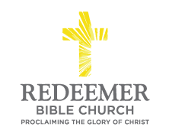
Angelo L. Tolentino / Resurrection Day Service / Redeemer Bible Church / Vista, CA / April 4, 2021

Intro:

- Preaching Point: God’s Word is given_____________________________ ____________________________________________________________.

- Who are y___________ in the eyes of G_______________?

  - Are you the c___________________ criminal? v39

  - Are you the r__________________ criminal? v40-43

- Who is J_______________ C________________? v40-43

Conclusion:

