John 4:19-26 “¹⁹ The woman said to Him, “Sir, I perceive that You are a prophet. Our fathers worshiped on this mountain, and yet you Jews say that in Jerusalem is the place where one must worship.” Jesus said to her, “Believe Me, woman, that a time is coming when you will worship the Father neither on this mountain nor in Jerusalem. You Samaritans worship what you do not know; we worship what we do know, because salvation is from the Jews. But a time is coming, and even now has arrived, when the true worshipers will worship the Father in spirit and truth; for such people the Father seeks to be His worshipers. God is spirit, and those who worship Him must worship in spirit and truth.” The woman said to Him, “I know that Messiah is coming (He who is called Christ); when that One comes, He will declare all things to us.” Jesus said to her, “I am He, the One speaking to you.”

Applications in Worship: Worship in Spirit and Truth
John 4:19-26
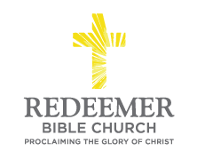
Angelo L. Tolentino / Morning Service / El Corazon Senior Center / Oceanside, CA / August 22, 2021

Intro:

- Preaching Point: God the Father has given you this passage ________________ __________________________________________________________________.

- F_______________ His L___________, v19-22

- G_______________ Your A__________, v23-25

- S______________ on J________________v25-26

Conclusion:

