¹⁰ “We have an altar from which those who serve the tabernacle have no right to eat. ¹¹ For the bodies of those animals whose blood is brought into the Holy Place by the high priest as an offering for sin are burned outside the camp. ¹² Therefore Jesus also suffered
outside the gate, that He might sanctify the people through His own blood. ¹³ So then, let us go out to Him outside the camp, bearing His reproach. ¹⁴ For here we do not have a lasting city, but we are seeking the city which is to come.”
Hebrews 13:10-14

Separation from the World
Hebrews 13:10-14
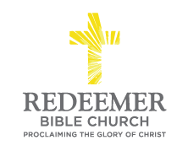
Angelo L. Tolentino / Morning Service / El Corazon Senior Center / Oceanside, CA / September 26, 2021

Intro:
Preaching Point: God gave this passage so that you would ______________
_______________________________________________________________
_______________________________________________________________
_______________________________________________________________

- _____________ _____________ of Separation, v10-11

- __________ ___________ for Separation, v12

- ________ _________ to Separation, v13

- ___________ _____________ for Separation, v14

Conclusion:

