Colossians 3:16
¹⁶ Let the word of ^{[a]}Christ richly dwell within you, ^{[b]}with all wisdom teaching and admonishing ^{[c]}one another with psalms, hymns, and spiritual songs, singing with thankfulness in your hearts to God.

The Applications of Worship, 2: Worshipping God in Song
Colossians 3:16
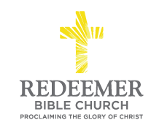
Angelo L. Tolentino / Morning Service / Redeemer Bible Church / Oceanside, CA / August 28, 2021

Intro:
- Preaching Point: God gave you this passage ______________________________
___________________________________________________________________.

- M ________________________in the W___________________, v16a

- E ____________________ the B ____________________, v16b

- L ________________ Your V ______________________, v16c

Preparing Yourself:
    - Are you marinating in the Word of Christ?
    - Are you personally worshiping Christ through Remembrance, Submission, and Service?

