Certain Without a Doubt
1 John 1:1-4
^{NAS} 1 John 1:1 What was from the beginning, what we have heard, what we have seen with our eyes, what we beheld and our hands handled, concerning the Word of Life-- ² and the life was manifested, and we have seen and bear witness and proclaim to you the eternal life, which was with the Father and was manifested to us-- ³ what we have seen and heard we proclaim to you also, that you also may have fellowship with us; and indeed our fellowship is with the Father, and with His Son Jesus Christ. ⁴ And these things we write, so that our joy may be made complete.
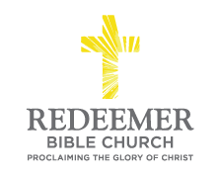
Angelo L. Tolentino / Morning Service / Meeting at The Classical Academy Online High School / Oceanside, CA / October 9, 2016

Intro:
- Preaching Point: God gave this passage so that you __________________ ________________ __________________________.

- God’s Truth Proves R______________________, v1-2

- God’s Truth Restores R_____________________, v3

- God’s Truth Brings R_______________________, v4

Conclusion:

