The Holy Spirit’s Gifts to the Local Church
1 Corinthians 12:8-11
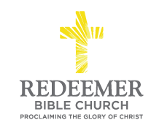
Angelo L. Tolentino / Morning Service / El Corazon Senior Center / Oceanside, CA / January 23, 2022

Intro:
⁸For to one is given the word of wisdom through the Spirit, and to another the word of knowledge according to the same Spirit; ⁹ to another faith by the same Spirit, and to another gifts of healing by the one Spirit, ¹⁰ and to another the effecting of miracles, and to another prophecy, and to another the distinguishing of spirits, to another various kinds of tongues, and to another the interpretation of tongues. ¹¹ But one and the same Spirit works all these things, distributing to each one individually just as He wills.
1 Corinthians 12:8-11

Preaching Point: God grants this passage this morning so that ____________
_________________________________________________________________
_________________________________________________________________

- ___________ the Holy Spirit to __________ a ___________ of _________ to the _________ __________, v8-10.

- ______________ the Holy Spirit __________ _______ _______ is ___________ to __________ _______________, v11.

Conclusion:

