⁴ “Now there are varieties of gifts, but the same Spirit. ⁵ And there are varieties of ministries, and the same Lord. ⁶ There are varieties of effects, but the same God who works all things in all persons. ⁷ But to each one is given the manifestation of the Spirit for the common good.”
1 Corinthians 12:4-7

God’s Spiritual Gifts to the Local Church
1 Corinthians 12:4-7
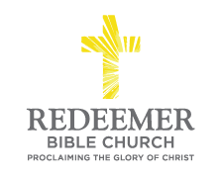
Angelo L. Tolentino / Morning Service / El Corazon Senior Center / Oceanside, CA / November 28, 2021
Intro:

Preaching Point: God gave this passage to you this morning so that each of you would _____________________________________________________
______________________________________________________________
______________________________________________________________

- Expect God to Use _____________ ____________ to Strengthen the Local Church, v4-6.

- Expect God to Use ______________ ____________ to Strengthen the Local Church, v7.

Conclusion:

