Exposing Counterfeit Spiritual Gifts
1 Corinthians 12:1-3
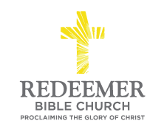
Angelo L. Tolentino / Morning Service / El Corazon Senior Center / Oceanside, CA / November 21, 2021

Intro:
“Now concerning
spiritual gifts, brothers and sisters,
I do not want you to be unaware. ² You know that when you were pagans, you were led astray to the mute idols, however you were led. ³ Therefore I make known to you that no one speaking by the Spirit of God says, “Jesus is accursed”; and no one can say, “Jesus is Lord,” except by the Holy Spirit.”
1 Corinthians 12:1-3

Preaching Point: God gave this passage to you so that you would ____________
____________________________________________________________________________________________________________________________________

- _______ in Your ___________ ___________ ________ Spiritual Gifts, v1.

- ______________ the ____________ of Counterfeit Spiritual Gifts, v2

- _______ _______ ___________ of Supposed Spiritual Gifts, v3

Conclusion:

