Running from Idolatry
1 Corinthians 10:14-22
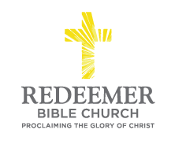
Angelo L. Tolentino / Morning Service / El Corazon Senior Center / Oceanside, CA / September 19, 2021

Intro:
- Preaching Point: God’s Word speaks __________________________________ _________________________________________________________________.

- Your Idolatry is C____________ C__________ to N________ L_______,
v16-18

- Your Idolatry is D____________ S______________ in N_____________,
v19-21

- Your Idolatry is H______________ O____________ to G____________,
v22

Conclusion:

