1 Corinthians 11:23-26

^{“23} For I received from the Lord that which I also delivered to you, that the Lord Jesus, on the night when He was betrayed, took bread; ²⁴ and when He had given thanks, He broke it and said, “This is My body, which is for you; do this in remembrance of Me.” ²⁵ In the same way He also took the cup after supper, saying, “This cup is the new covenant in My blood; do this, as often as you drink it, in remembrance of Me.” ²⁶ For as often as you eat this bread and drink the cup, you proclaim the Lord’s death until He comes.”

The Elements of Worship: Remembering God
1 Corinthians 11:23-26
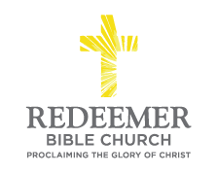
Angelo L. Tolentino / Morning Service / El Corazon Senior Center / Oceanside, CA / June 19, 2021

Intro:

- Preaching Point: God has given these passages so that you would _________ _______________________________________________________________.

- God D_________________ Remembrance for You.

- God D_____________________ Remembrance for You.

- God D__________________ Remembrance from You.

Conclusion:

