1 Corinthians 6:9-11
“⁹ Or do you not know that the unrighteous will not inherit the kingdom of God? Do not be deceived; neither the sexually immoral, nor idolaters, nor adulterers, nor ^{[a]}homosexuals, ¹⁰ nor thieves, nor the greedy, nor those habitually drunk, nor verbal abusers, nor swindlers, will inherit the kingdom of God. ¹¹ Such were some of you; but you were washed, but you were sanctified, but you were justified in the name of the Lord Jesus Christ and ^{[b]}in the Spirit of our God.”

The Transformed Life in Christ
1 Corinthians 6:9-11
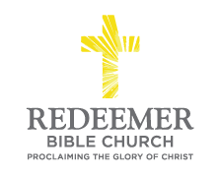
Angelo L. Tolentino / Morning Service / Bagalso Residence / Oceanside, CA / February 21, 2021

Intro:
- Preaching Point: From this passage, God’s call on you ____________________ __________________________________________________________________.

- B__________ of the L________ of the U_________________ Life, v9-10

  - The Lie E______________, 9a-9b, 10f

  - The Lie M_______________, v9c-10e

- D__________ on the T___________ of the T_______________ Life, v11

  - The Transformation D_______________

  - The Transformation E_______________

Conclusion:

